**Task No. 1:** Create 4 Components Each Component contains at least 5 Classes

**Solution:**

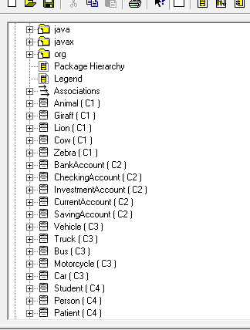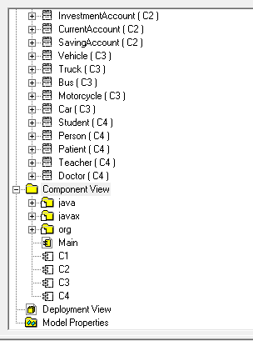

**Task No. 2:** Add Attributes and Operations in Classes for Forward Engineering

**Solution:**

**Component 1:**

//Source file: C:\mutayyab\C2.java

private class BankAccount

{

private String AccountName;

private int Balance;

public BankAccount(){}

public void Deposi(){}

public void withdraw(){}

}

private class CheckingAccount

{

private int LastCheckNum;

public BankAccount theBankAccount;

public CheckingAccount(){}

}

private class InvestmentAccount

{

private String AccountRep;

public BankAccount theBankAccount;

public InvestmentAccount(){}

public void Withdraw(){}

}

private class CurrentAccount

{

private int minimumBalance;

public BankAccount theBankAccount;

public CurrentAccount(){}

}

private class SavingAccount

{

private Float Interestrate;

public BankAccount theBankAccount;

public SavingAccount(){}

}

**Component 2:**

//Source file: C:\mutayyab\C2.java

private class BankAccount

{

private String AccountName;

private int Balance;

public BankAccount(){}

public void Deposi(){}

public void withdraw(){}

}

private class CheckingAccount

{

private int LastCheckNum;

public BankAccount theBankAccount;

public CheckingAccount(){}

}

private class InvestmentAccount

{

private String AccountRep;

public BankAccount theBankAccount;

public InvestmentAccount(){}

public void Withdraw(){}

}

private class CurrentAccount

{

private int minimumBalance;

public BankAccount theBankAccount;

public CurrentAccount(){}

}

private class SavingAccount

{

private Float Interestrate;

public BankAccount theBankAccount;

public SavingAccount(){}

}

**Component 3:**

//Source file: C:\mutayyab\C3.java

private class Vehicle

{

private String Model;

private String name;

private String Owner;

private String Make;

public Vehicle(){}

public int CalcMileage()

{

return 0;

}

public int CalcUsedPrice()

{

return 0;

}

}

private class Truck

{

private int maxSpeed;

private int PassengerCapacity; private int NoOfTyres;

public Vehicle theVehicle;

public Truck(){}

public void doorOpen(){}

public void doorClose(){}

}

private class Bus

{

private int PassengerCapacity; private String Ac;

public Vehicle theVehicle;

public Bus(){}

public void doorOpen(){}

public void doorClose(){}

}

private class Motorcycle

{

private String ignitionType; private int cc;

private int Price;

public Vehicle theVehicle;

public Motorcycle(){}

}

private class Car

{

private boolean AC; private String Automatic;

private int HorsePower; public Vehicle theVehicle;

public Car(){}

public void doorClose(){}

public void doorOpen(){}

}

**Component 4:**

//Source file: C:\mutayyab\C4.java

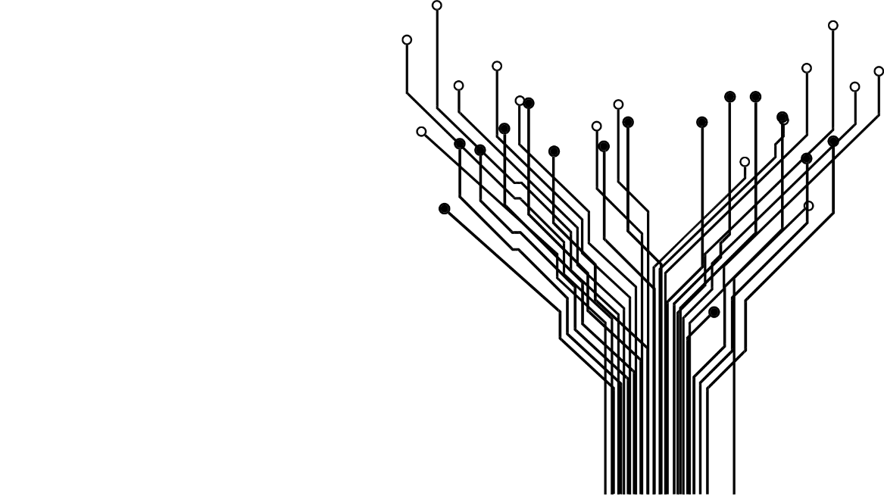 private class Student

{

private int id;

private String major;

private int courses;

private String SchoolName;

public Person thePerson;

public Student(){}

public void RegisterCourses(){}

public void appearsInExams(){}

}

private class Person

{

private String Name;

private int age;

private String Nationality;

private String address;

private int Height;

private int weight;

public Person(){}

public void walk(){}

public void talk(){}

public void eat(){}

public void sleep(){}

}

private class Patient

{

private String disease;

private String previousRecord;

private String doctorName;

private String alergies;

public Person thePerson;

public Patient(){}

public void payBill(){}

public void beChecked(){}

}

private class Teacher

{

private String id;

private String FacultyType;

private int CourseTeaches;

private int Salary;

public Person thePerson;

public Teacher(){}

public void Make_Quiz(){}

public void TeachStudents(){}

}

private class Doctor

{

private int id;

private String Experience;

private String speicaity;

private String WorksAt;

public Person thePerson;

public Doctor(){}

public void OperatePatients(){}

public void prescribeMedicines(){}

}

**Task No. 3:** Add more operations and Attributes via Coding in JAVA language for Alll Classes and Apply Reverse Engineering for changing Class Diagram

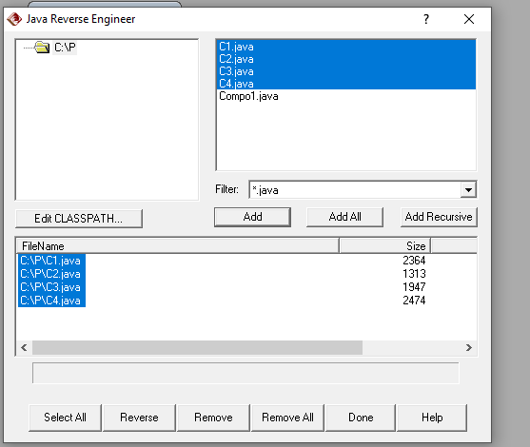**Solution:**

